**INTRODUCTION**

**A facial recognition system is a technology capable of identifying a person from a digital image from a still source. There are multiple methods in which facial recognition systems work, but in general, they work by comparing selected facial features from given image with faces within a database.**

**The face recognition system can be divided into two main stages: face verification (or detection), and face identification (or recognition). The detection stage is the first stage; it includes identifying and locating a face in an image.**

**The recognition stage is the second stage; it includes feature extraction, where important information for discrimination is saved, and the matching, where the recognition result is given with the aid of a face database.**

**It is natural, easy to use and does not require aid from the test subject. Properly designed systems installed in airports, multiplexes, and other public places can detect presence of criminals among the crowd. Other biometrics like fingerprints, iris, and speech recognition cannot perform this kind of mass scanning.**

**There are facing major security issues, consequently, they need several specially trained personnel to attain the desired security. These personnel, as human beings, make mistakes that might affect the level of security. A proposed solution to the aforementioned matter is a Face Recognition Security System, which can detect intruders to restricted or high-security areas, and help in minimizing human error.**

**When a person enters to the zone in question, a series of snapshots are taken by the camera and sent to the software to be analyzed and compared with an existing database of trusted people. An alarm goes off if the user is not recognized.**

**FACE RECOGNITION is one of the hypotheses of high variability of the shape to detect. Many new detection techniques and face recognition methods are studied and implemented in an efficient way, with the work of Viola and Jones. The OBJECT of this project is to implement on the CPU with C/C++, using OpenCV.**

**The other Objective of this project is to demonstrate**

* **Handle camera set-up, calliberate and recognize still faces**
* **Pre-processes images and extract their features**
* **Perform face recognition by**

**A) Trying new techniques.**

**B) Existing methods**

**Other way, a second implementation in FGPA was presented Keywords-Face detection, method of Viola/Jones, C/C++, OpenCV, FPGA .Using this application we will try access control, identification system and law enforcement applications. . A highly accurate face recognition system requires a number of complex sub-operations to be performed. This technology is used in many fields such as biometrics for identification and recognition face, later which is explained in our project.**

**LITERATURE**

**PROJECT DEFINITION:-**

**A facial recognition system is a technology capable of identifying a person from a digital image from a still source. There are multiple methods in which facial recognition systems work, but in general, they work by comparing selected facial features from given image with faces within a database. The face recognition work as to recognize faces in an image**

Existing System:-

**There are many techniques to recognize faces, with the help of these techniques, we can identify faces with higher accuracy. These techniques have an almost same procedure for Face Detection such as OpenCV, Matlab, etc.**

SYSTEM SPECIFICATION:

Hardware

* Pentium IV (dual core processor operating at 3.6 GHz) or above

200MB hard disk or above.

* 512 MB RAM or above.

Software

* Sublime Text editor3
* Xamp**.**
* **Operation System-Windows XP or above**
* **OpenCV**

**FEASIBILITY STUDY**

**Scope:-**

The required image processing through face recognition for any criminal activities shall be fulfilled.

**Users:-**

This site can be used by 3 types of users:

**Admin**

The project manager has the options to add users, access user information, project information, assign information, report, self details.

**Authorized member:-**

The developer has an option to view projects and self details.

**Local user:-**

The tester has to add information in the assigned projects and to view his projects, self details.

**Requirements:-**

**Portability: -**

The system will be designed to be portable across popular Windows OS.

**Extensibility:-**

The system should be extensible to add further information and users for more expansion.

**Re-Usability:-**

The system’s code could be reused to add further new features if need to be added in future.

**DESIGN PRINCIPLES & EXPLANATION**

**MODULES**

The main goal of this project is to store detect face and process images given by the user and those in the database. This will be used for future reference for social awareness and issues. The project has the following modules:

* Admin
* Authorized Member
* Local User

**MODULE DESCRIPTION**

**Admin -**

The admin has the options to add users, access user information, project information, assign information, report, self details.

**User Information:-**

The admin will access the user information. In this the, the project manager can

* Add user details into the database.
* Delete user from the database.
* Modifying the existing user.

**Project Information:-**

The admin will access the project information. In this, the project admin can:

* Add the project into the database by gathering the information like images, information, age, name and previous details
* Delete the requires information from the database.
* Modify the project details if required by the authorized user.

**Assign Information:-**

This can be accessed by the admin to assign the details to the other users like authorized user and local user. Assign information has the following options like view, assign and modify. The admin can

* View all the database details of the person(criminal).
* Assign the case information to the authorized user for detailing the information of a person.

**Report:-**

This is used to view the person (criminal) details by using the provided id only by the admin and the authorized user.

**PROPOSED SYSTEM**

The aim of proposed system is to develop a system of improved facilities for the local users. The proposed system can overcome all the limitations of the existing system. The system  
provides proper security and reduces the manual work.

ADVANTAGES OF THE PROPOSED SYSTEM   
the system is very simple in design and to implement. The system requires very low  
system resources and the system will work in almost all configurations. It has got  
following features with basic of security of data:

• Ensure data accuracy’s

• Proper control of the higher officials.

• Reduce the damages of the machines.

• Minimize manual data entry.

• Minimum time needed for the various processing.

• Greater efficiency.

• Better service.

• User friendliness and interactive.

• Minimum time required.

**LIST OF FIGURES**

1.1 CONTEXT LEVEL DIAGRAM

1.2 LEVEL 1 DFD FOR LOCAL USER

1.3 LEVEL 2 DFD FOR AUTHORISED MEMEBER

1.4 LEVEL 3 DFD FOR ADMIN

1.5 CASE DIAGRAM FOR LOCAL USER

1.6 CASE DIAGRAM FOR AUTHORISED MEMBER

1.7 CASE DIAGRAM FOR ADMIN

1.8 FLOW CHART

1.9 CLASS DIAGRAM

2.1 SEQUENCE DIAGRAM

2.2 SEQUENCE DIAGRAM

* 1. **CONTEXT LEVEL DIAGRAM**

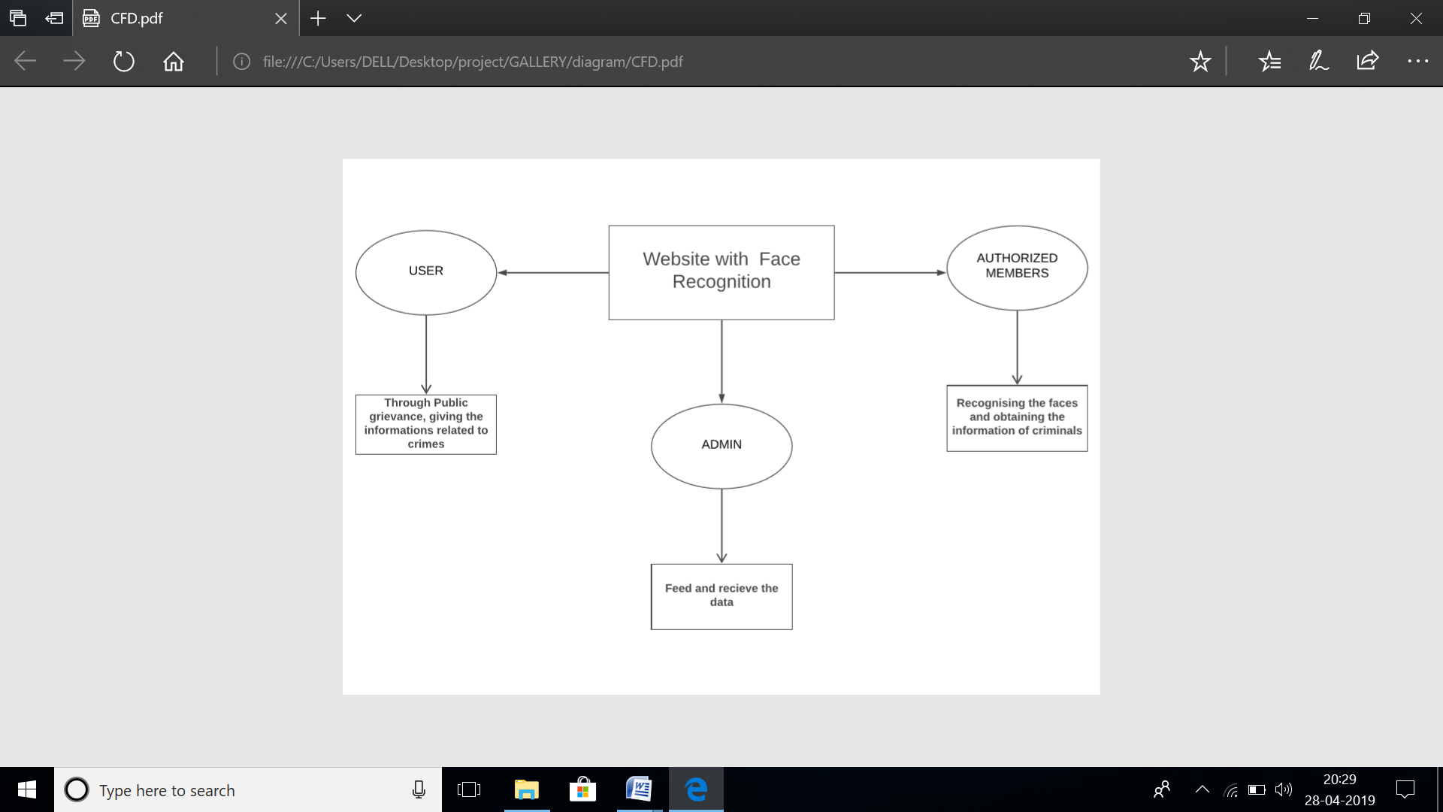

**DATA FLOW DIAGRAMS**

A Data Flow Diagram (DFD) is a graphical technique that depicts information flow and the transforms that are applied as data move from input to output.

Data flow diagram is a logical model of a system. The model does not depend on hardware, software, and data structure or file organization. It only shows the data flow between modules to module of the entire system

* 1. **LEVEL 1 DFD FOR LOCAL USER**

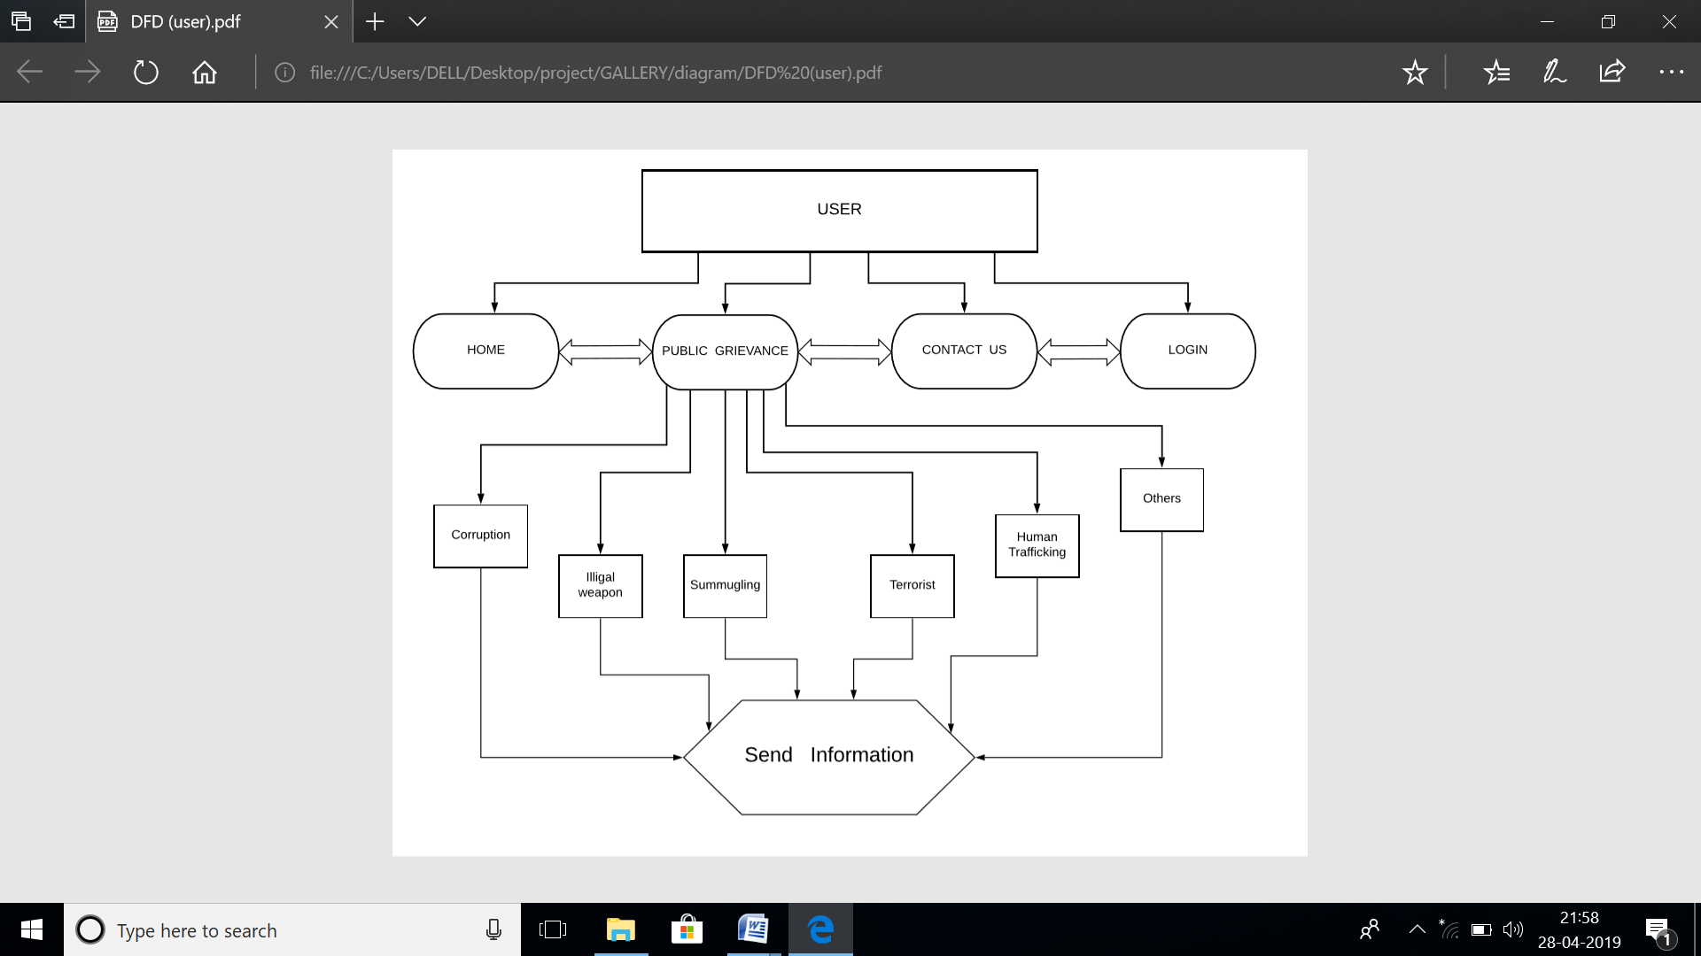

* 1. **LEVEL 2 DFD FOR AUTHORISED MEMBER**

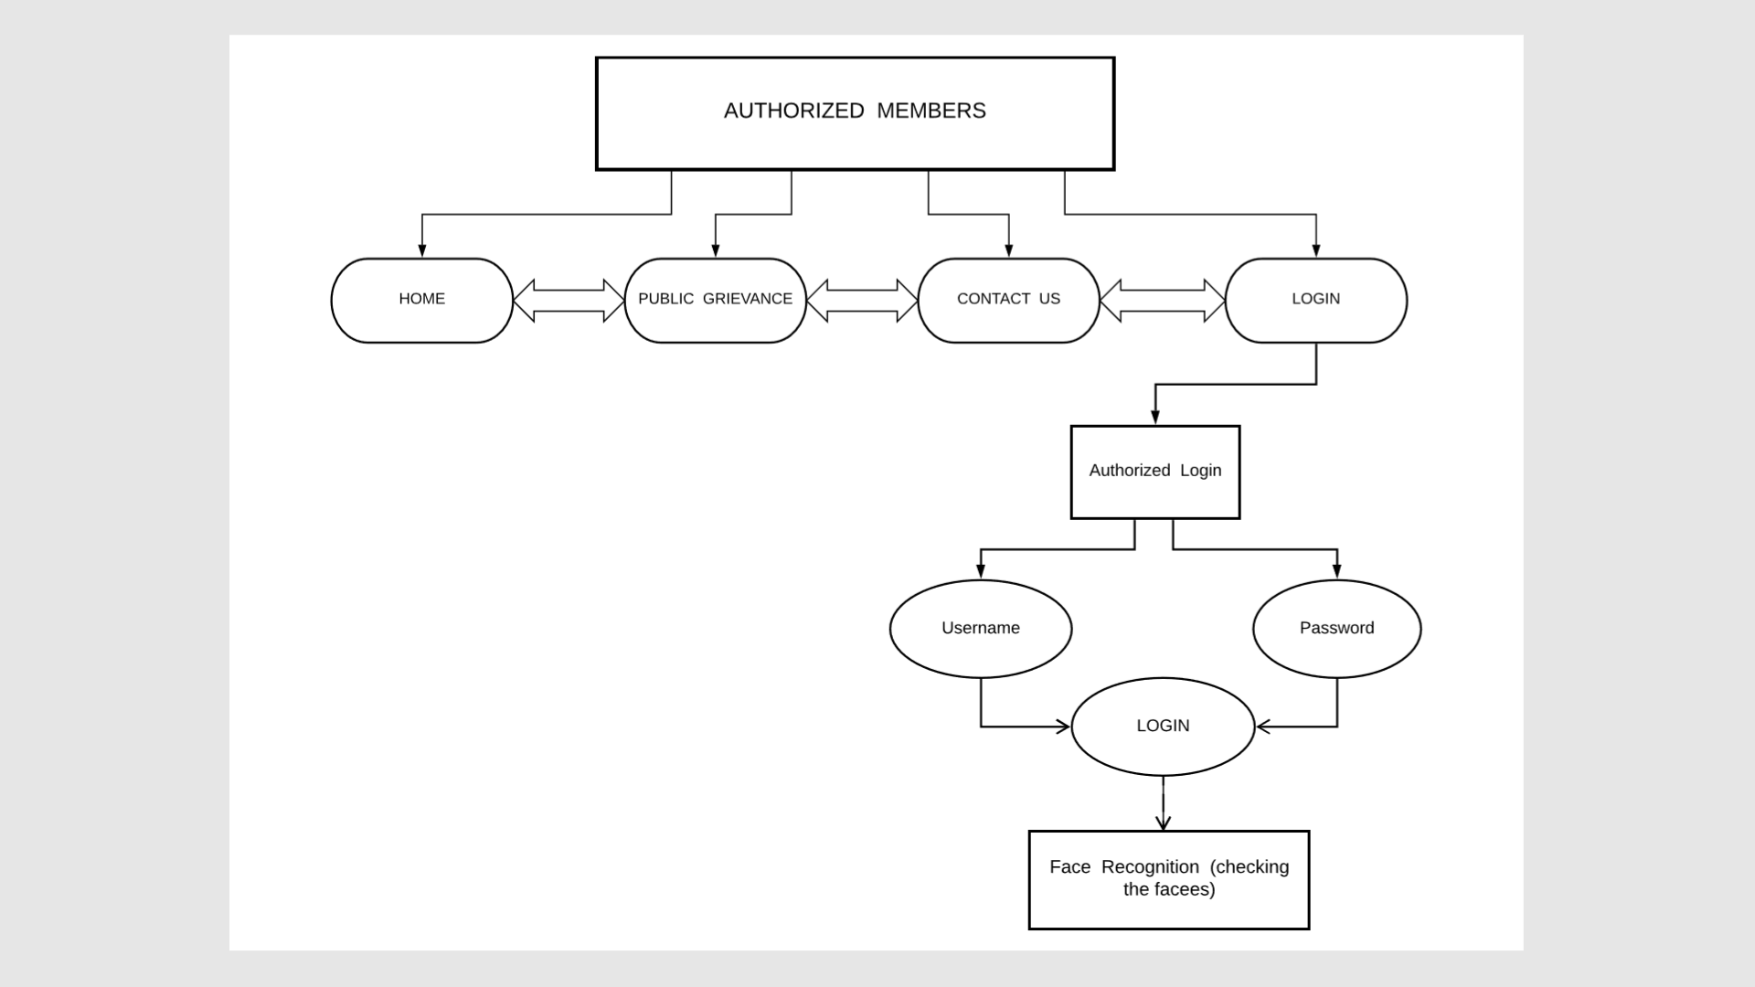

* 1. **LEVEL 3 DFD FOR ADMIN**

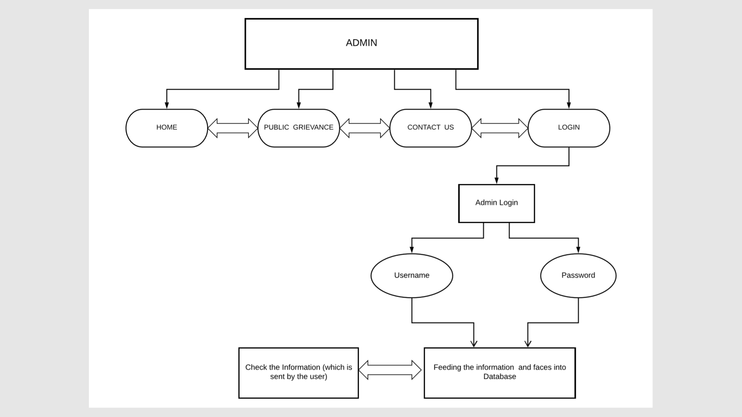

**1.5 CASE DIGARAM FOR LOCAL USER**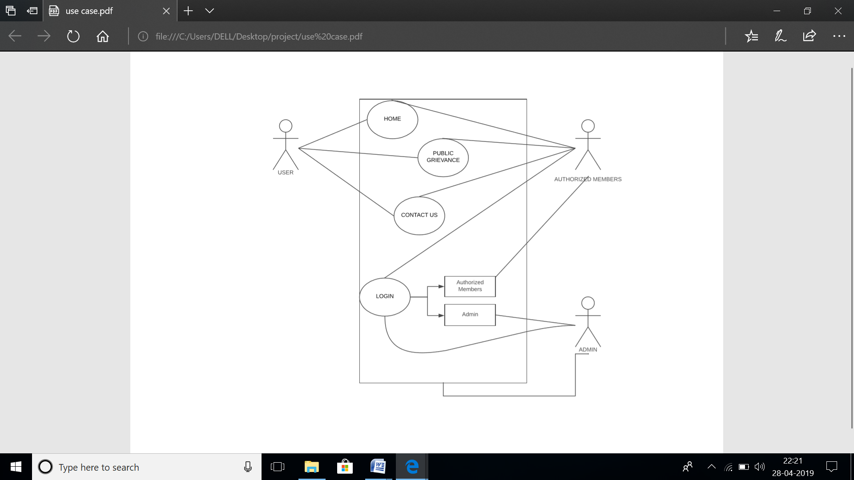

**1.6 CASE DIAGRAM FOR AUTHORIZED MEMEBER**

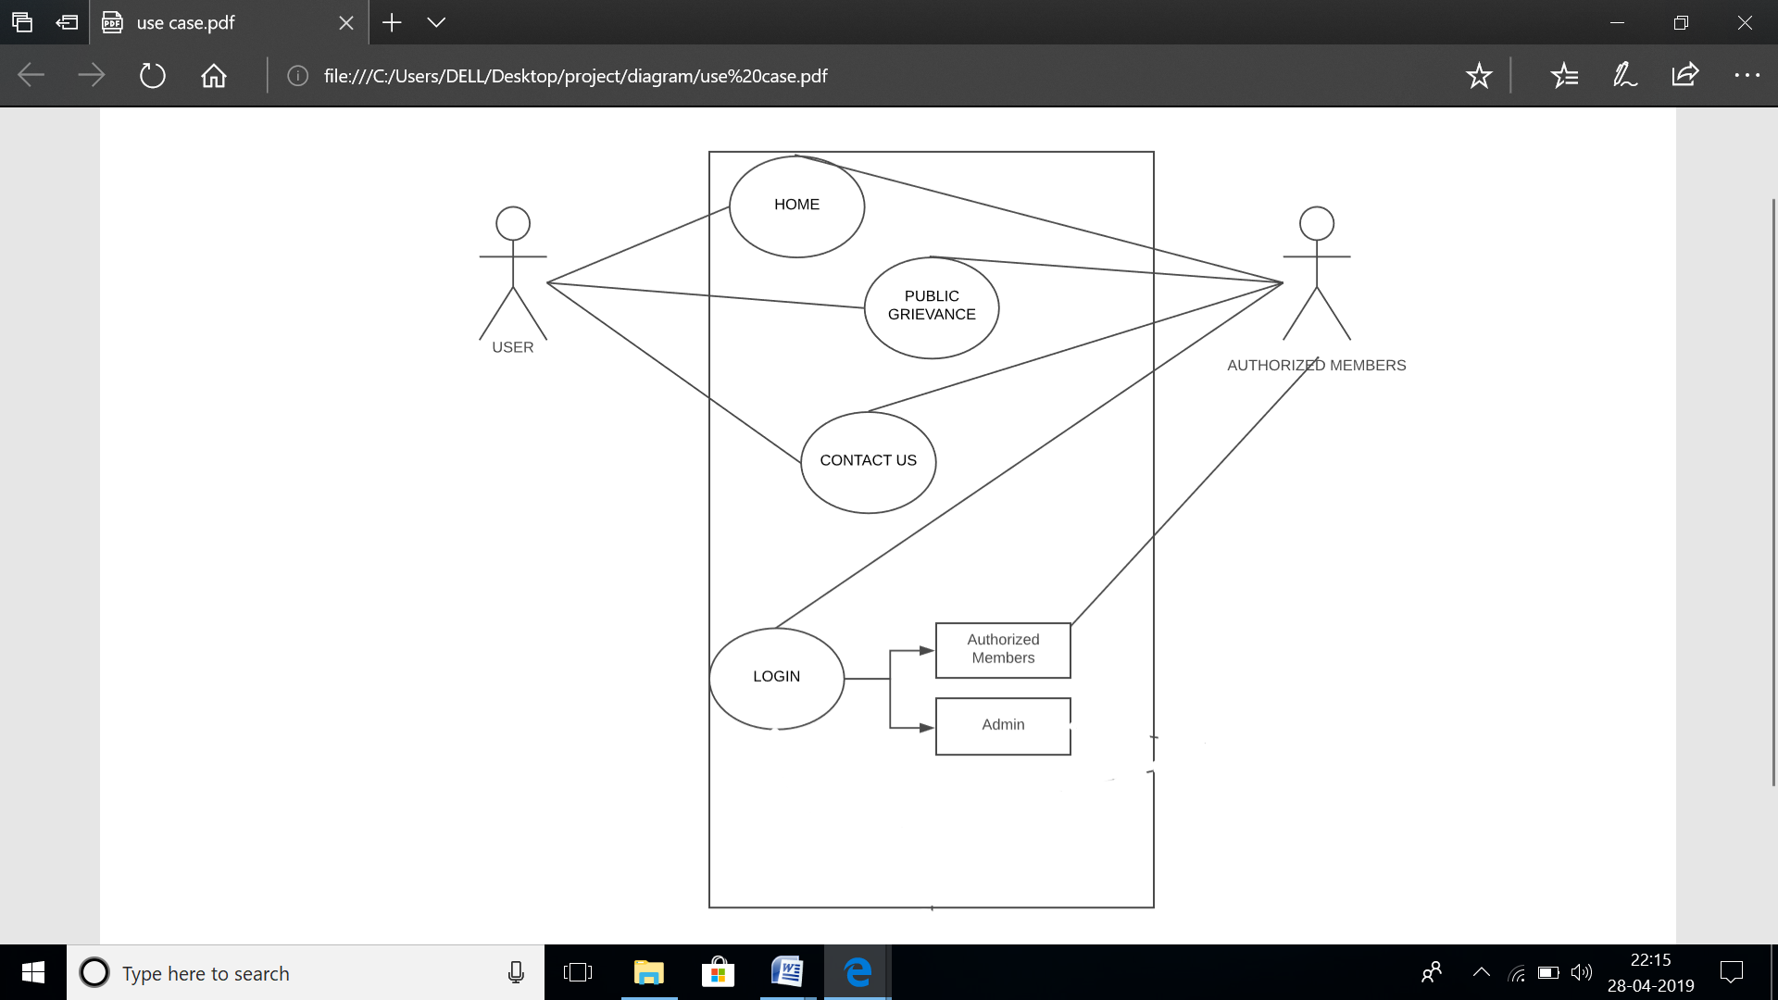

**1.7 CASE DIAGRAM FOR ADMIN**

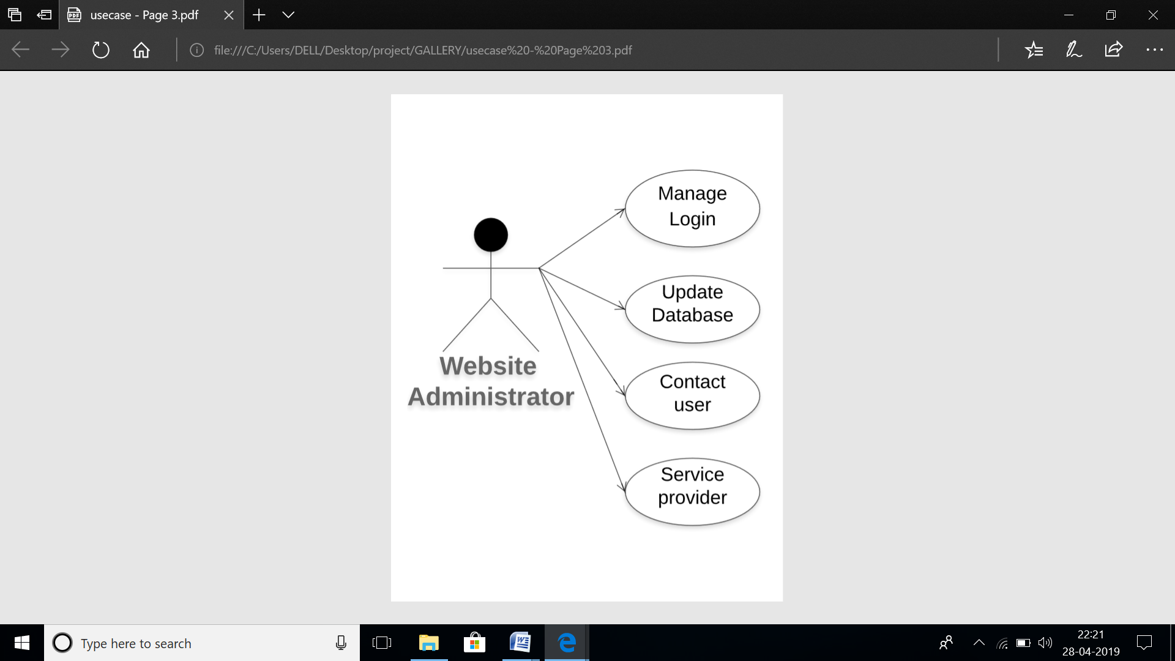

**1.8 FLOWCHART**

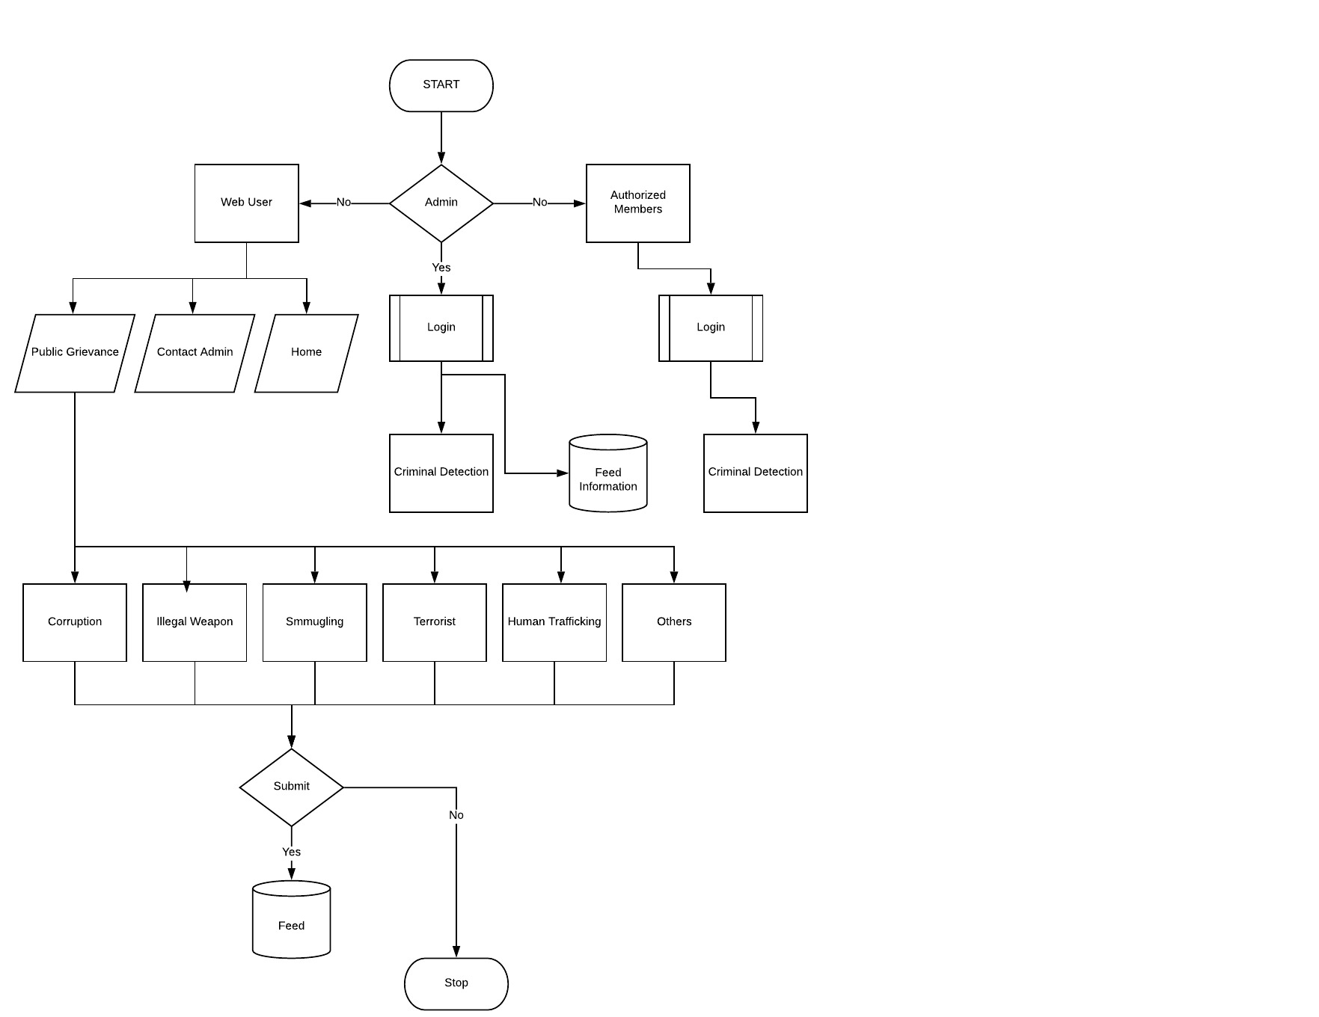

**1.9 CLASS DIAGRAM**

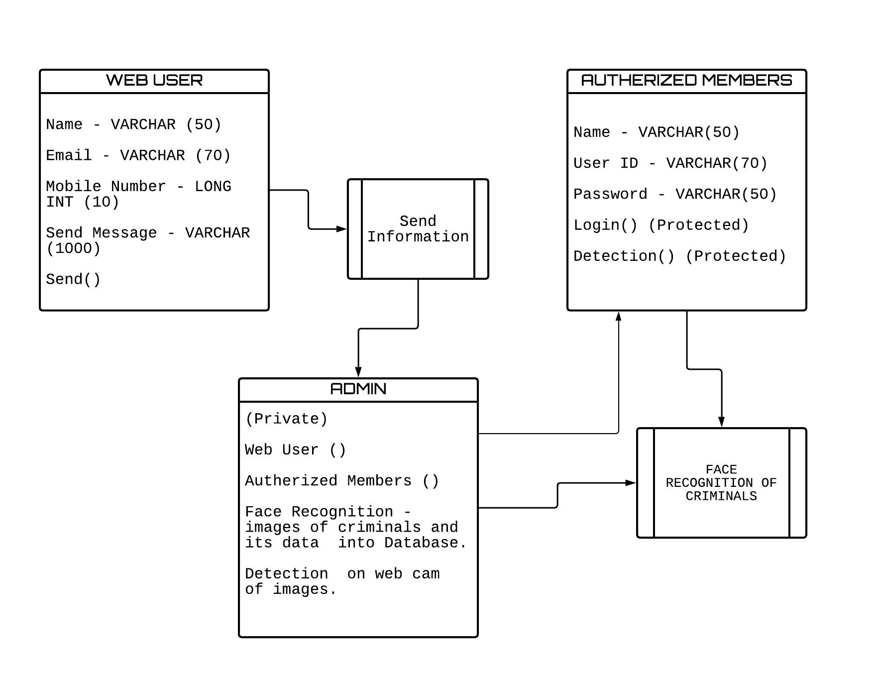

**2.1 SEQUENCE DIAGRAM FOR USER**

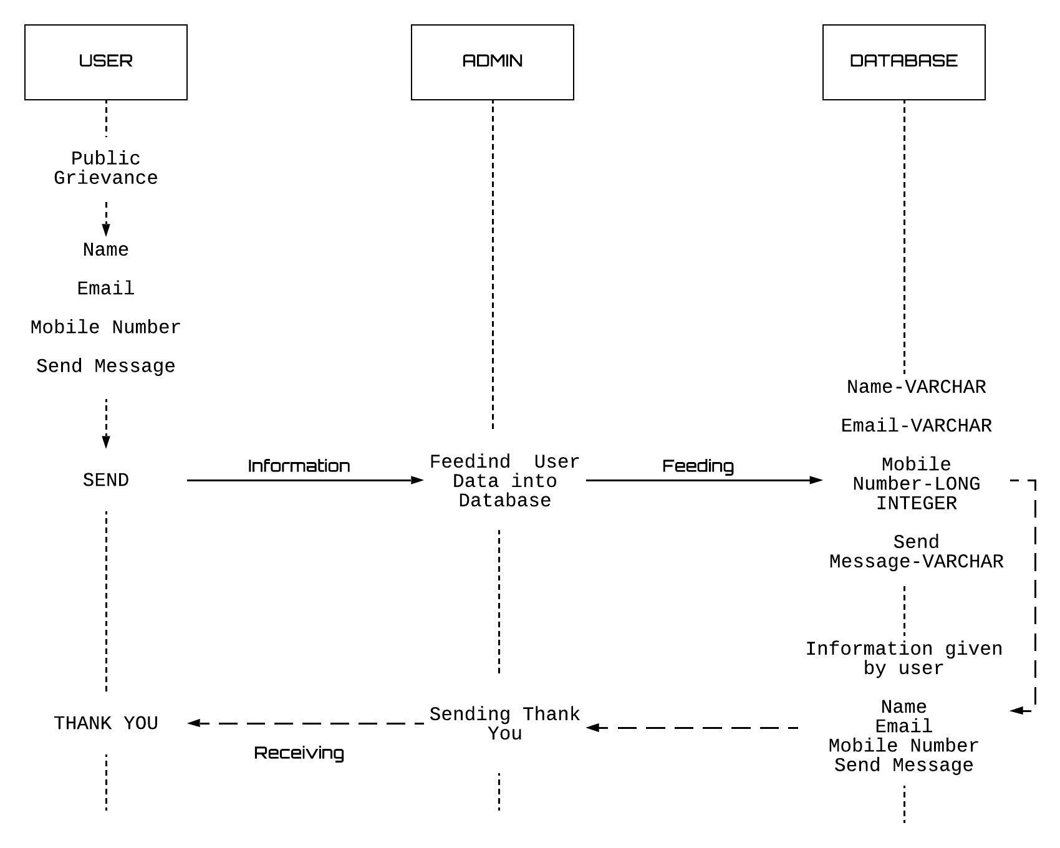

**2.2 SEQUENCE DIAGRAM FOR AUTHORISED MEMBER**

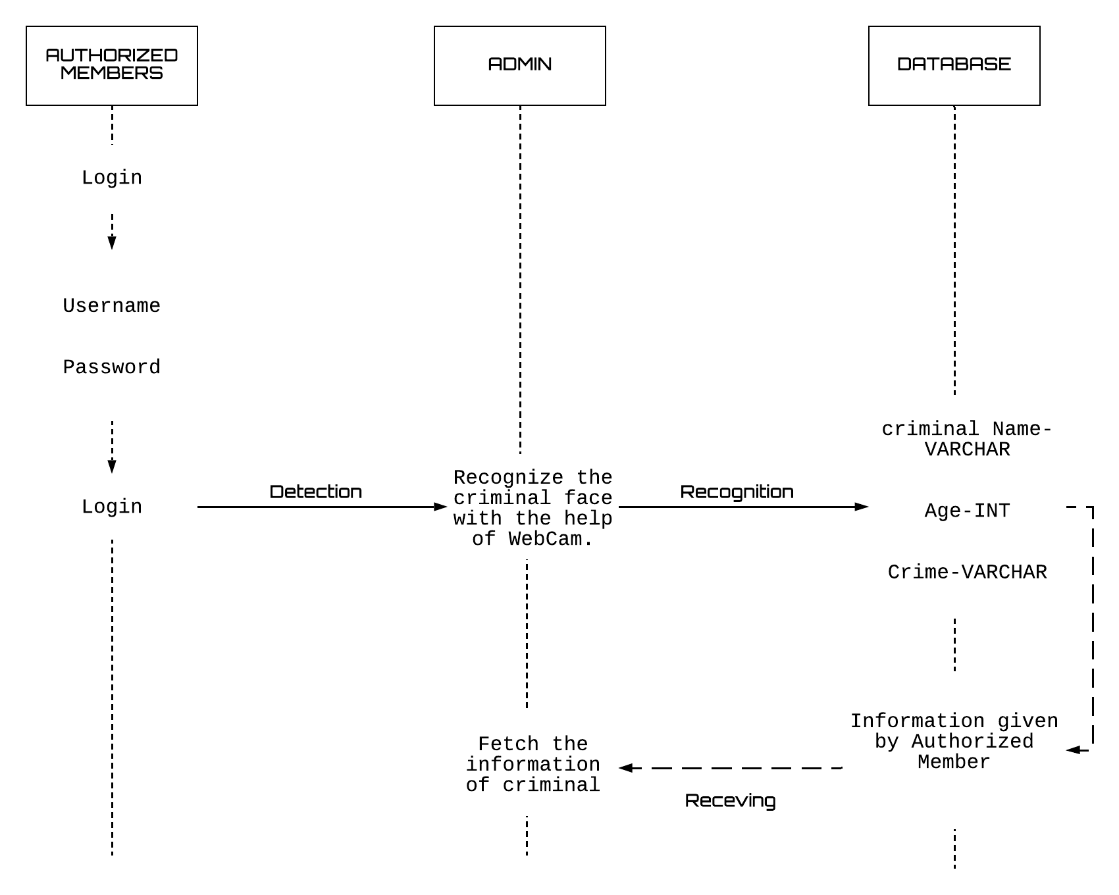

**RESULTS**

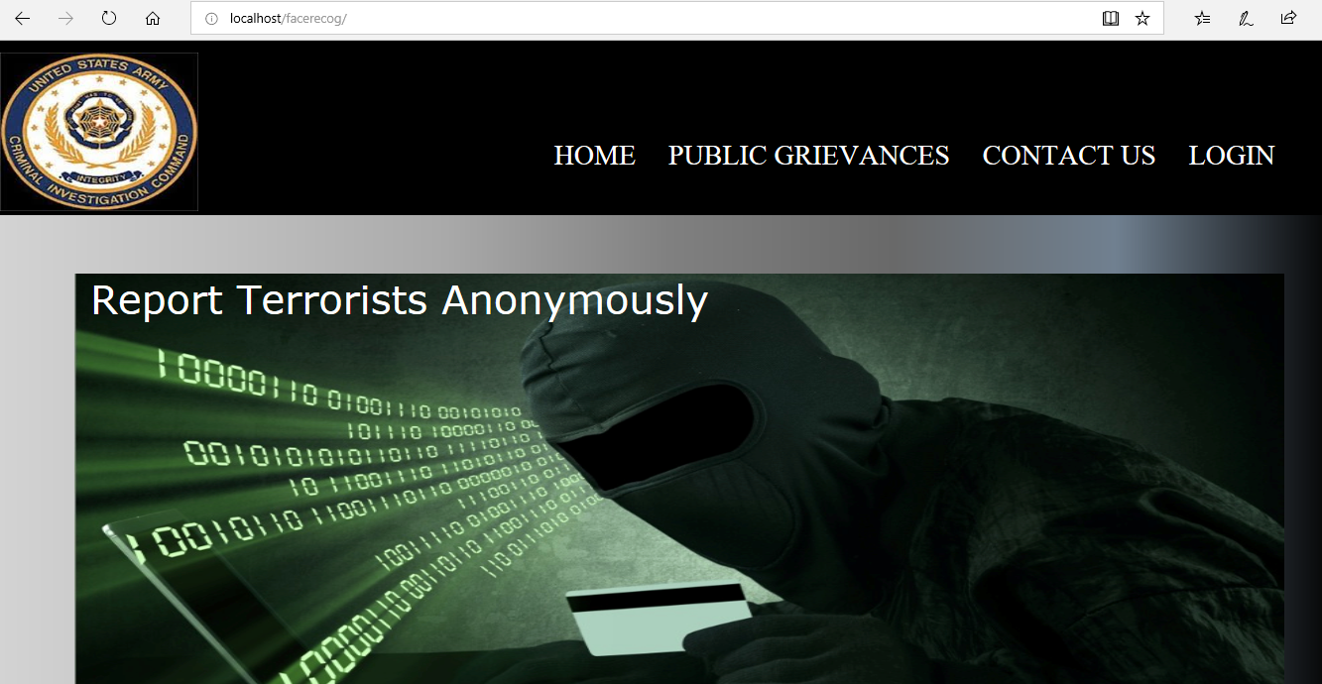

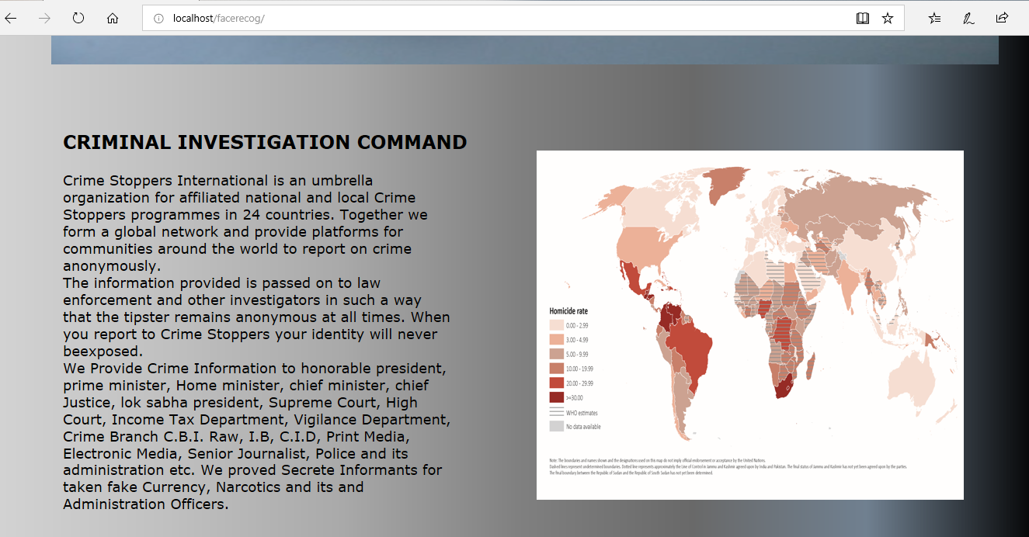

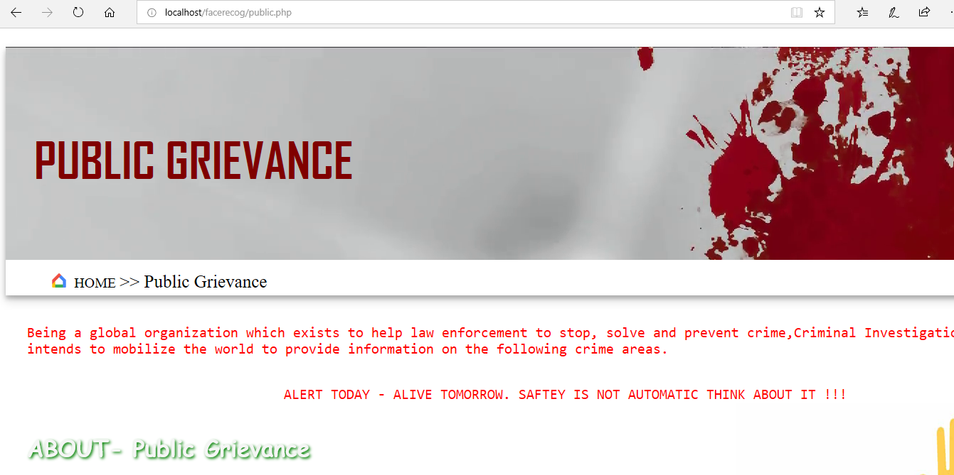

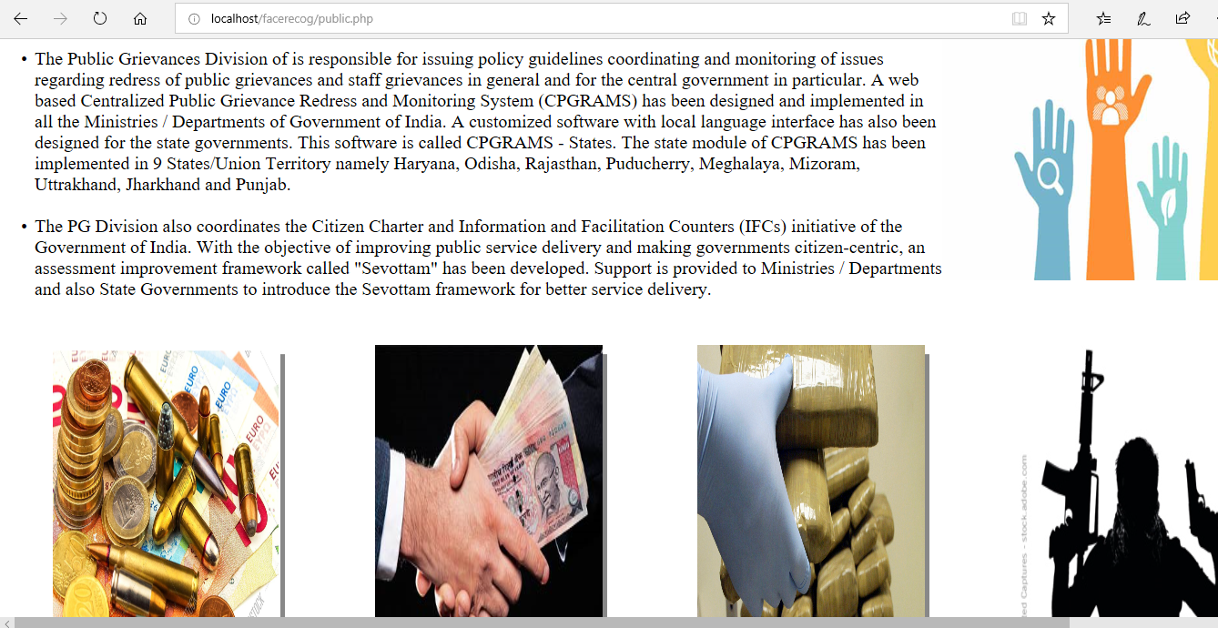



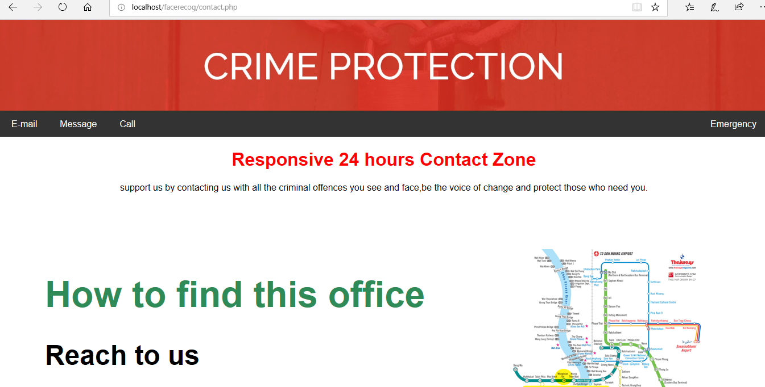

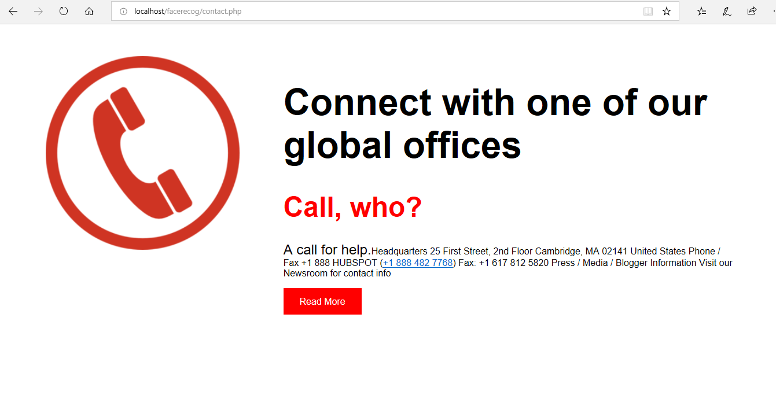

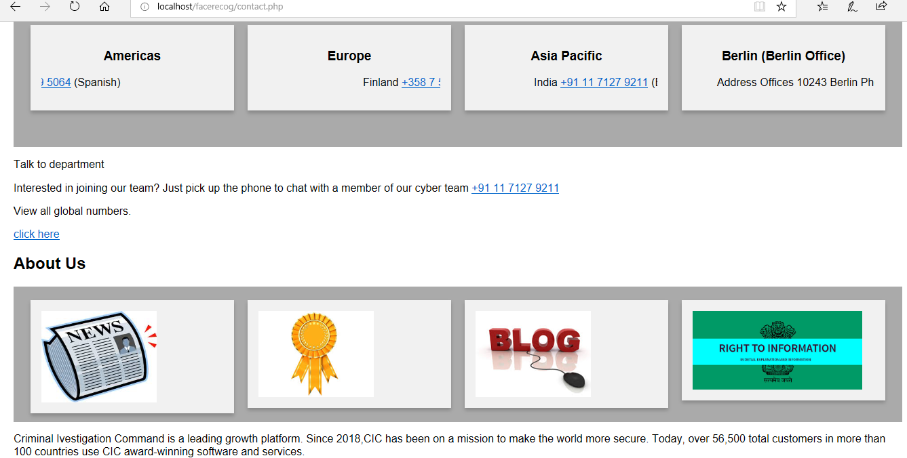

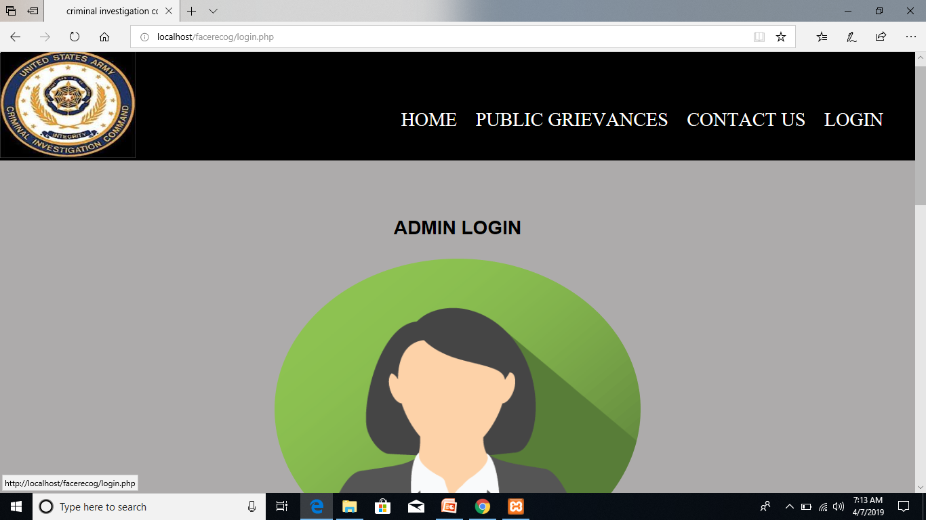





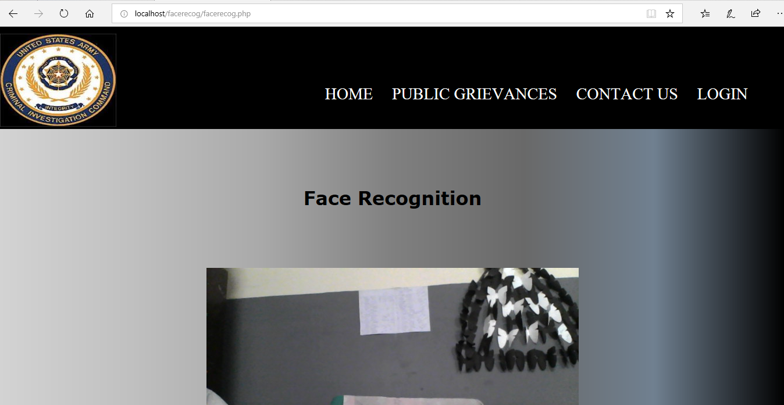

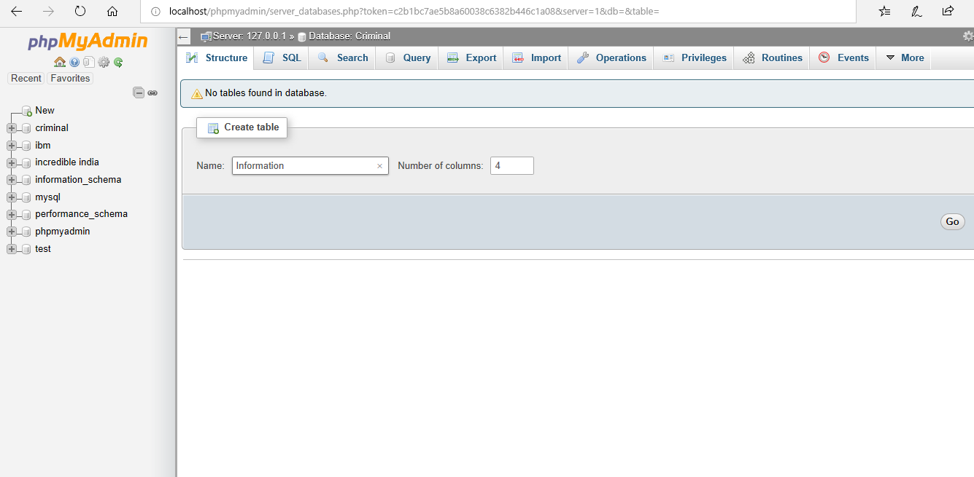

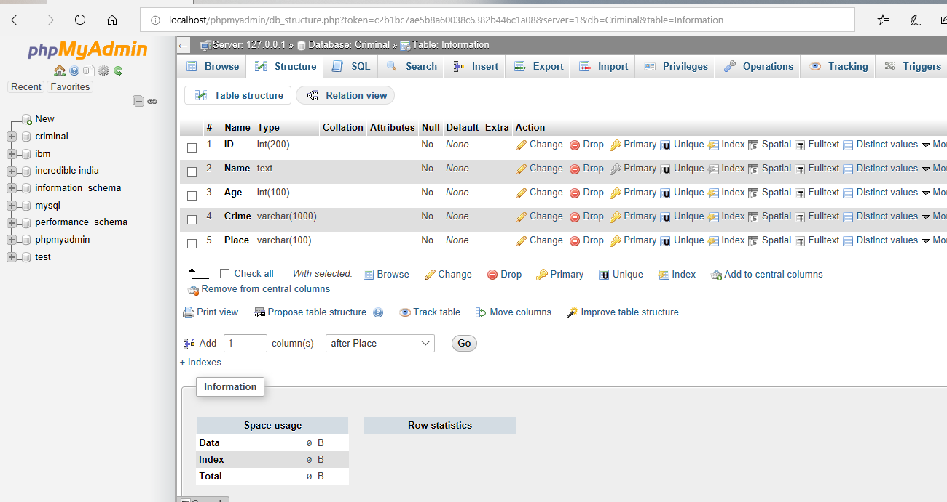

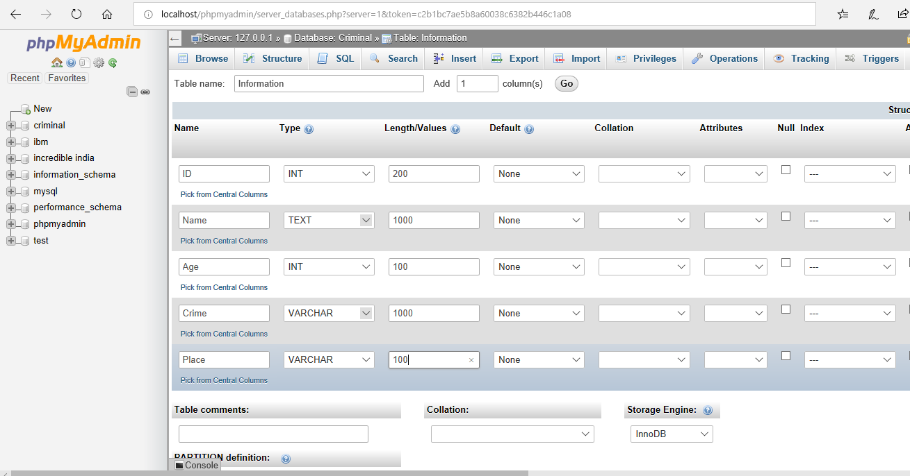

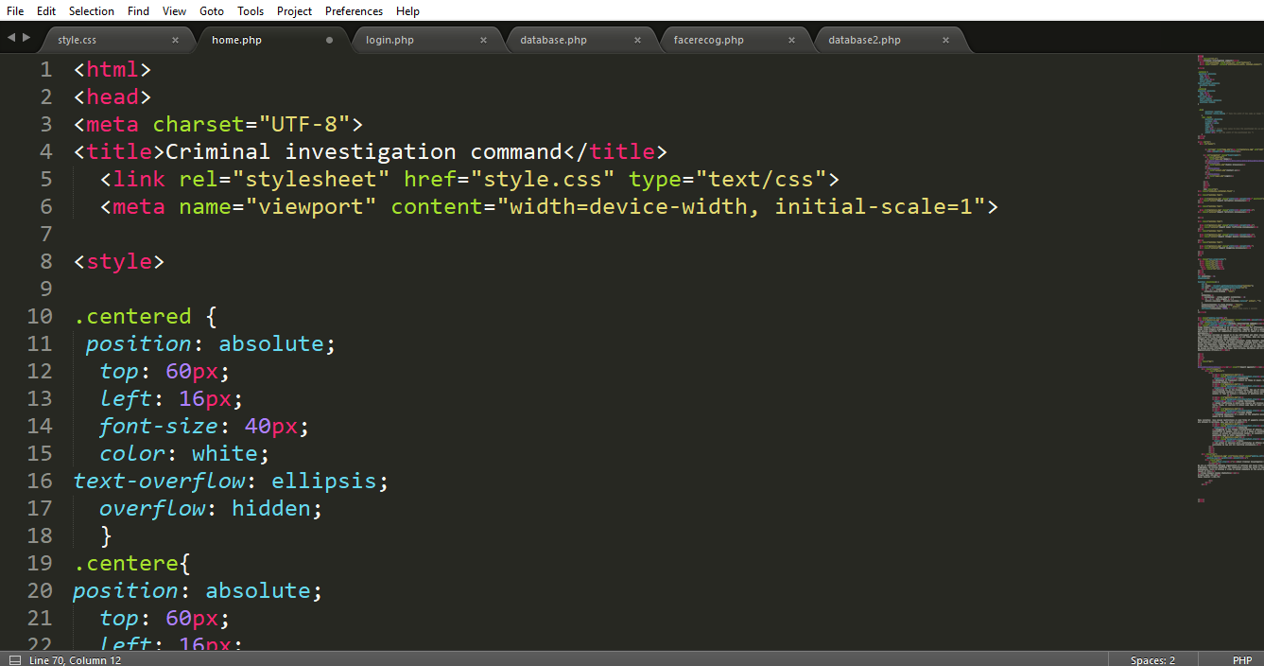

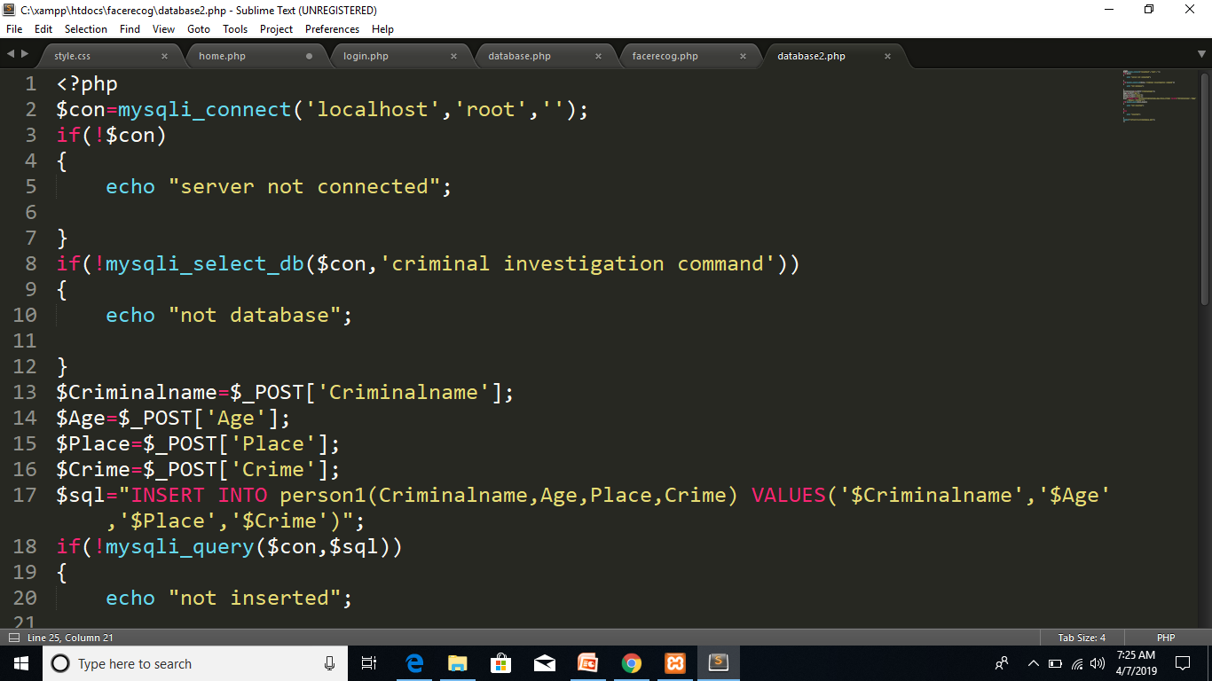

**FUTURE SCOPE**

**The other Objective of this project is to demonstrate**

* **Handle camera set-up, calliberate and recognize still faces**
* **Pre-processes images and extract their features**
* **Perform face recognition by**

**A) Trying new techniques.**

**B) Existing methods.**

* Conducting National Entrance Examinations:- It can be used as

Student ID.

* Airport Security checks:-To check the fake passport cases.
* Social Media.
* Preventing crime in retail.
* Identify Missing people.
* CCTV cameras will soon be outfitted with facial recognition technology that can automatically identify and track individual’s face in public

**CONCLUSION**

In this course, the issues that arise in bringing a criminal, no matter his/her age, should be dealt with according to the crime. The legal system is too lenient when it comes to juvenile offenders. Laws need to be rewritten immediately so that no more hard core criminals go free just because they are juveniles.

This website deals with such issues so that people can feed criminals information no matter what age group they belong to. This helps to reduce the crime rate of any country.

Now it’s clear about the need and importance of such website, it not only helps to identify criminals but also identify missing people in need.

Therefore in nutshell the correct definition of this project can be given as:

* A facial recognition system that uses biometrics to map facial features from photograph or video.
* It compares the information with a database of known faces to find a match.

**REFERENCES**

* Internet, for website designs.
* Previous project, from training period.
* W3school, for html styling
* Code pen, for database connectivity